CMS Queries

1—> Show manager name, branch name, income, expense and profit of top 3 branches compared to previous month profits

select e.first_name , e.last_name , mainRes.branch_id, mainRes.branch_name, mainRes.income, mainRes.totalexpense, mainRes.profit from

(select first_name, last_name, branch_id from "CMS".employee where designation_id=1) as e

join

(select b.branch_id,b.branch_name,resBranch.income,resBranch.totalExpense,(resBranch.income-resBranch.totalExpense)as profit from "CMS".branch as b

join

(select amount.branchID,(amount.courierAmount) as income, (amount.agencyAmount + expense.expensAmount) as totalExpense from

(select sending_branch_id as branchID, sum(courier_payment_amount)as courierAmount , sum(agency_payment_amount)as agencyAmount from "CMS".transaction where

extract(year from courier_delivery_datetime) = (extract(year from current_date)) and

extract(month from courier_delivery_datetime) = (extract(month from current_date)-1)

group by sending_branch_id) as amount

join

(select (ex.expens+emp.salaryAmount)as expensAmount,ex.branch_id from

(select sum(amount)as expens,branch_id from "CMS".expenses where

extract(year from expense_date) = (extract(year from current_date)) and

extract(month from expense_date) = (extract(month from current_date)-1)

group by branch_id) as ex

join

(select sum(salary) as salaryAmount,branch_id from "CMS".employee group by branch_id)as emp

on(emp.branch_id = ex.branch_id))as expense

on(expense.branch_id = amount.branchID)

)as resBranch

on(b.branch_id = resBranch.branchID)

)as mainRes

on(mainRes.branch_id = e.branch_id) order by mainRes.profit desc limit 3;

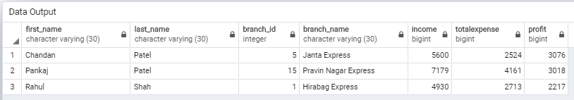

2—>Show transport agencies who deliver to every state across the country

select tran.*from"CMS".transport_agency as tran join

(select tr.transport_id from "CMS".transport_agency as tr

except

(select res.agency_id from

(

(select t.agency_id, s.state_id from "CMS".state as s cross join (select DISTINCT agency_id from "CMS".agency_route) as t)

except

(select DISTINCT ar.agency_id,c.state_id from "CMS".city as c join "CMS".agency_route as

ar on(c.city_id=ar.to_city_id))

)as res

)

) as mr

on(tran.transport_id = mr.transport_id)

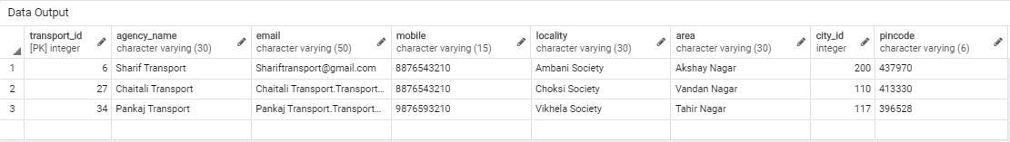

3—>Show the branch details and manager name which has got a courier from 2 days but still pending to deliver

select mr.branch_name,m.first_name,m.last_name,mr.mobile,mr.city_name,mr.totelPendingCouriers from

(select * from "CMS".employee where designation_id = 1) as m

join

((select b.branch_id,b.branch_name ,b.mobile,c.city_name from "CMS".branch as b

join "CMS".city as c on(c.city_id = b.city_id))as br

join

(select reciver_branch_id,count(transaction_id)as totelPendingCouriers from "CMS".transaction

where transport_status_id=3

and extract(day from age(agency_delivery_date,current_date)) > 3

group by reciver_branch_id) as reslt

on (br.branch_id = reslt.reciver_branch_id)) as mr

on(m.branch_id = mr.branch_id);

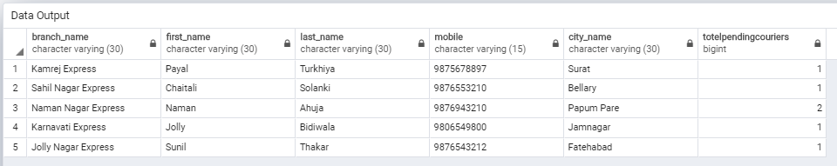

4—> Show employee name and salary who has delivered more than 5 couriers in current month

select e.first_name,e.last_name,e.branch_id,e.salary,t.totalDelivery from

(select deliver_employee_id,count(transaction_id)as totalDelivery from "CMS".transaction where

transport_status_id = 4 and

extract(year from courier_delivery_datetime) = (extract(year from current_date)) and

extract(month from courier_delivery_datetime) = (extract(month from current_date)-1)

group by deliver_employee_id having count(transaction_id) > 5

) as t join

(select employee_id,first_name, last_name, branch_id,salary from "CMS".employee where designation_id =3)as e

on (t.deliver_employee_id=e.employee_id) ;

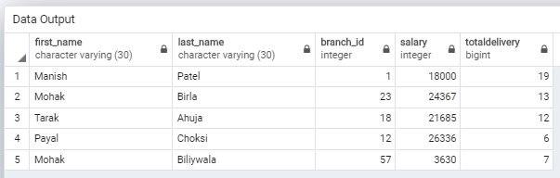

5-->Show the monthly courier average of year wise for a specific branch

select res.year,trunc(avg(res.num),1)as monthly_AVG from(select extract(year from courier_pickup_datetime)as year, count(transaction_id)as num from "CMS".transaction

where sending_branch_id = 22

group by extract(year from courier_pickup_datetime) , extract(month from courier_pickup_datetime)) as res

group by res.year

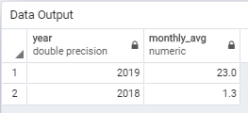

6—>Show currently working people in a particular branch

select * from "CMS".employee where branch_id = 1 group by employee_id having extract(day from age(job_endling_date,job_starting_date))=-1;

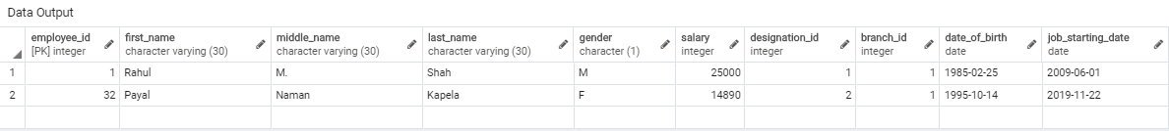

7—>Show all manager names with their branch names

select ee.first_name,b.branch_name from "CMS".branch as b join

(select e.first_name, e.branch_id from "CMS".employee as e join

(select d.designation_id from "CMS".designation as d where d.designation_name = 'manager') as r

on (e.designation_id = r.designation_id)

) as ee on (ee.branch_id = b.branch_id);

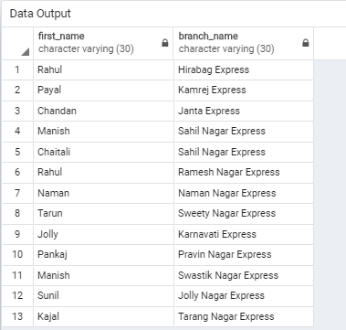

8—>Count all branches in particular state

select s.state_name, res.branches from "CMS".state as s join

(select state_id , sum(b.per_city)as branches from "CMS".city as c join

(select city_id, count(branch_id)as per_city from "CMS".branch group by branch_id) as b

on(b.city_id=c.city_id) group by (c.state_id)

)as res

on (s.state_id = res.state_id);

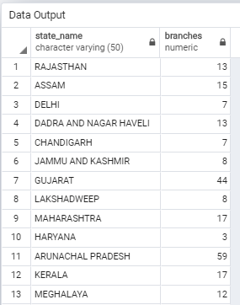

9—>Show all branch names in which more than 5 couriers are pending to deliver

select b.branch_name , reslt.totelPendingCouriers from "CMS".branch as b join

(select reciver_branch_id, count(courier_id)as totelPendingCouriers from "CMS".transaction

where transport_status_id = 1 group by(reciver_branch_id) having count(courier_id) > 5

) as reslt

on (b.branch_id = reslt.reciver_branch_id);

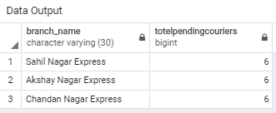

10—>Show the top 3 customers based on number of couriers in particular branch

select cl.first_name,cl.last_name,cl.mobile,client.Courier from

(select c.client_id,count(c.courier_id)as Courier from "CMS".courier as c

where c.branch_id =5 group by c.client_id order by Courier desc limit 3)as client

join "CMS".client as cl on (cl.client_id = client.client_id)

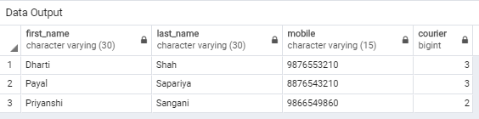

11->Show the top 5 customers based on maximum return of couriers

select * from "CMS".client as ci join

(select c.client_id, count(c.courier_id)as totalCount from "CMS".courier as c join

(select courier_id from "CMS".transaction where transport_status_id =5) as t

on(t.courier_id = c.courier_id) group by c.client_id order by totalCount desc limit 5) as result

on (ci.client_id=result.client_id);

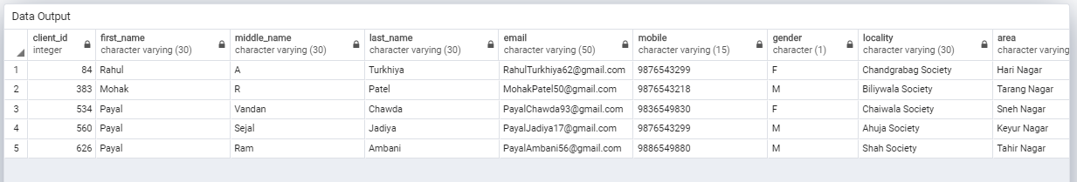

12—>Show the expenses of current month of branch no 5

select branch_id,sum(amount)as total_expense from"CMS".expenses where branch_id=5

AND extract(year from expense_date) = extract(year from current_date) and

extract(month from expense_date) = extract(month from current_date)

group by branch_id;

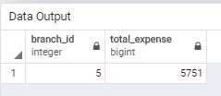

13—>Show those couriers for which payment to transport agency is remaining in particular branch

select courier_id from"CMS".transaction where sending_branch_id=8 and payment_id = 0 and courier_pickup_datetime<>agency_pickup_date;

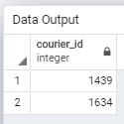

14—>Show the total number of clients in a particular area of the city

select area, count(client_id)noOfClient from "CMS".client

where city_id = 212 group by area;

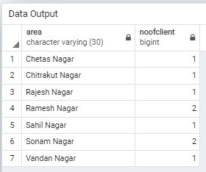

15—>Show top 5 branches and their income compared to previous month income

select b.branch_id,b.branch_name,resBranch.income from "CMS".branch as b join

(select amount.sending_branch_id as branch_id,(amount.courierAmount) as income from

(select sending_branch_id, sum(courier_payment_amount)as courierAmount from "CMS".transaction where

extract(year from courier_delivery_datetime) = (extract(year from current_date)) and

extract(month from courier_delivery_datetime) = (extract(month from current_date)-1)

group by sending_branch_id

) as amount

)as resBranch

on(b.branch_id = resBranch.branch_id) order by resBranch.income desc limit 5;

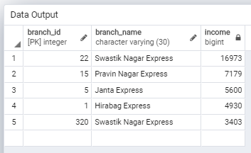

16—>Show top 5 branches and their expense compared to previous month's expense

select b.branch_id,b.branch_name,res.expenseAmount from "CMS".branch as b join

(select branch_id as branch, sum(amount)as expenseAmount from "CMS".expenses where

extract(year from expense_date) = (extract(year from current_date)) and

extract(month from expense_date) = (extract(month from current_date)-1)

group by branch_id

) as res

on(b.branch_id = res.branch) order by res.expenseAmount desc limit 5;

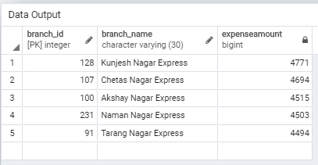

17—>Show all transport agencies which are connected to all surat city branches

select t.*from"CMS".transport_agency as t join

(select transport_id from "CMS".transport_agency where city_id=212

except

(select transport_id from

(select * from (select branch_id from "CMS".branch where city_id = 212)as b

cross join (select transport_id from "CMS".transport_agency where city_id = 212) as a

except

select * from "CMS".agency_branch_connection

)as res

)

)as mr

on(t.transport_id = mr.transport_id)

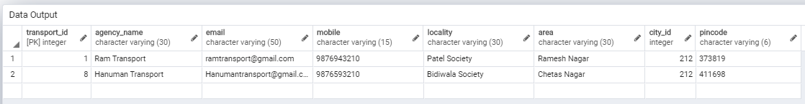

18—>Show employees excluding manager whose salary are more than the average salary of their branch

select * from "CMS".employee as e where designation_id <> 1 and salary >

(select avg(salary) from "CMS".employee where branch_id = e.branch_id group by branch_id)

